K9R243/1X2S11

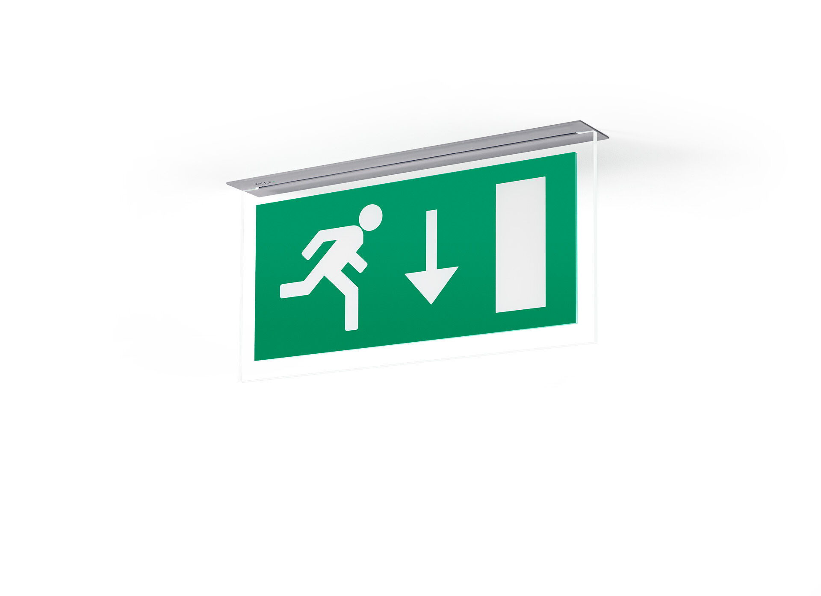
Minimalistic design emergency luminaire for single- and double sided signage. Recessed mounted. Autonomous luminaire (contains battery). Dimensions: 324 mm x 46 mm x 60 mm. Powder coated zamak housing, screwless opening, automatic electrical connection, screwless wire terminals (up to 2.5 mm²). Signage plate with illuminated borders. Lumen output in emergency mode: 80 lm. Power consumption in standby: 2.4 W. Voltage: 220-230V. The perception distance of the pictogram is 26 m. Autonomy: 60 minutes. The luminaire contains lamp data, battery date and type as required according to EN 60598-2.22. Battery: 4 x NiMh 1,2V 1,1Ah. Battery lifetime: 6 years. Automatic functional test every week, duration test every 13 weeks, in accordance to EN 50172 and EN 62034. Monitoring and control via DALI for central maintenance. Connection via two wire BUS communication. Maintained/non maintained mode selectable, preset for most common application. Electrical insulation class: class II. Photobiological safety IEC/TR 62778: RG0. Powder coated die-cast zamak housing, RAL9006 - white aluminium (textured). IP protection level: IP42. IK protection level: IK04. Ambient temperature: 5°C - 35°C. Glowwire: 850°C. 5 years warranty on luminaire, light source, driver and battery (for autonomous luminaires). Certifications: CE, ENEC. The luminaire has been developed and produced according to standard EN60598-1 in a company that is ISO9001 and ISO14001 certified.

