K1R12/3N-230C3

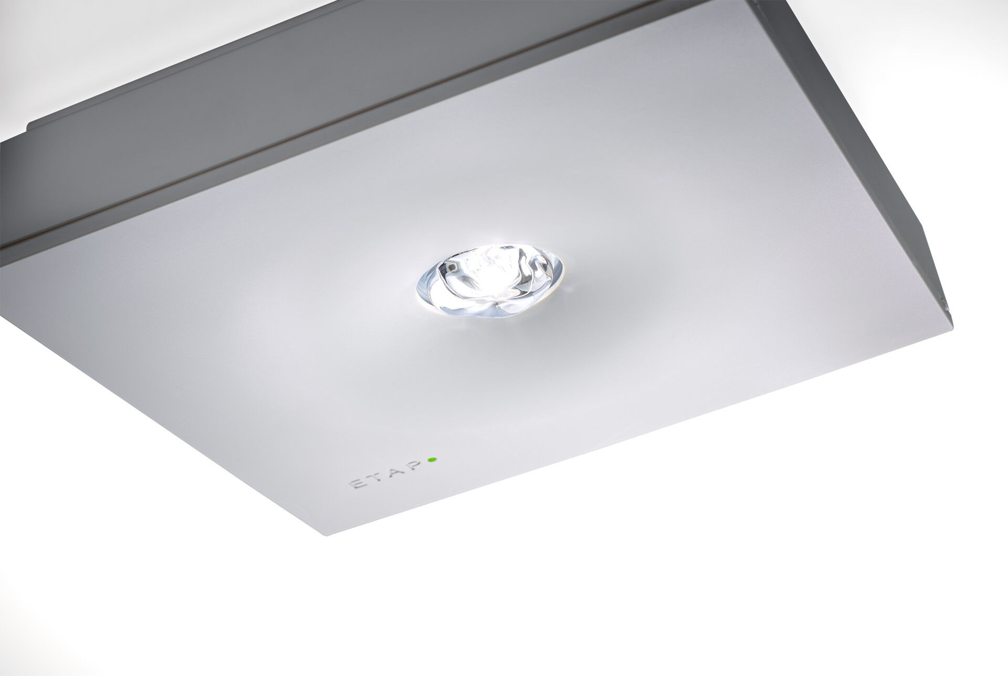
Square emergency luminaire for anti-panic lighting. Surface mounted. For central supply. Dimensions: 152 mm x 152 mm x 38 mm. Polycarbonate housing with sunk optics and flush aspect, screwless opening, automatic electrical connection, screwless wire terminals (up to 2.5 mm²), optional accessories for recessed mounting, four break-out ports Ø13mm. Square light distribution, optimized to avoid dark spots. Lumen output in emergency mode: 300 lm. Power consumption in standby: 4.8 W. Interdistance anti-panic: at a mounting height of 2.8 m, the illumination on the floor is 0.5 lux with an interdistance ("b") of 12.7 m. At a mounting height of 2.8 m, the illumination on the floor is 1 lux with an interdistance ("b") of 12.1 m. Voltage: 220-230V. Contains addressable MSÜ3 communication module, for use with a central battery system. Electrical insulation class: class II. Photobiological safety IEC/TR 62778: RG1. Impact-resistant polycarbonate housing, RAL9003 - signal white. IP protection level: IP42. IK protection level: IK04. Ambient temperature: -10°C - 35°C. Glowwire: 850°C. 5 years warranty on luminaire, light source, driver and battery (for autonomous luminaires). Certifications: CE, ENEC. The luminaire has been developed and produced according to standard EN60598-1 in a company that is ISO9001 and ISO14001 certified.

