K1M15-2

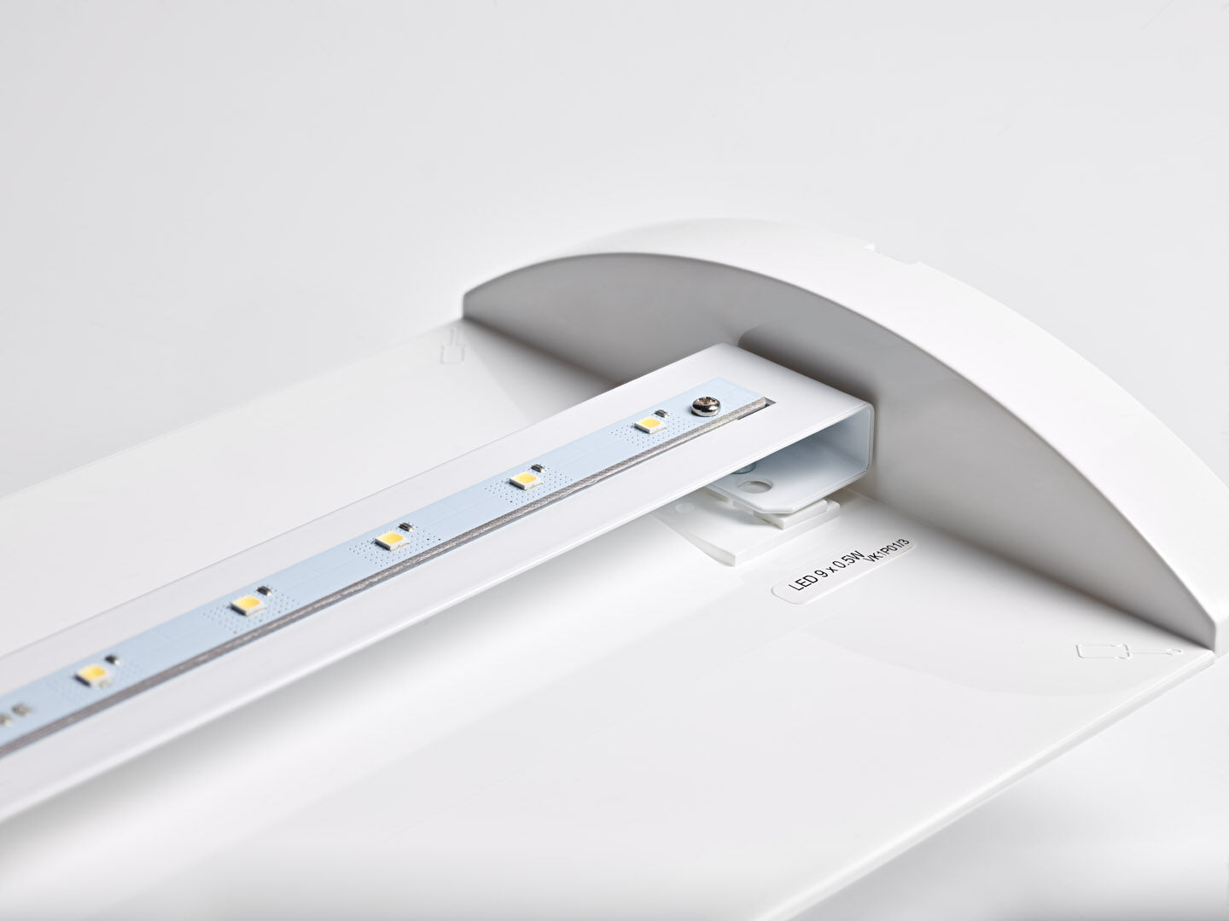
Renovation module to led for ETAP K1 and K2 fluo emergency lighting Autonomous luminaire (contains battery). Dimensions: . Plug-and-play, screwless replacement of the interior, exterior housing and wiring are kept as-is. Concentrated light distribution, optimized for high mounting or staircase illumination. Lumen output in emergency mode: 575 lm. Power consumption in standby: 2.3 W. Voltage: 220-230V. The perception distance of the pictogram is 0 m. Autonomy: 60 minutes. The luminaire contains lamp data, battery date and type as required according to EN 60598-2.22. Battery: 4 x NiMh 1,2V 2,2Ah. Battery lifetime: 10 years. Automatic functional test every week, duration test every 13 weeks, in accordance to EN 50172 and EN 62034. Monitoring and control via ESM software for central maintenance. Connection via wireless 868 MHz communication. Maintained/non maintained mode selectable, preset for most common application. Electrical insulation class: class II. Photobiological safety IEC/TR 62778: RG0. . Glowwire: 850°C. 5 years warranty on luminaire, light source, driver and battery (for autonomous luminaires). Certifications: CE. The luminaire has been developed and produced according to standard EN60598-1 in a company that is ISO9001 and ISO14001 certified.

