D2C-S300-13-840-015D

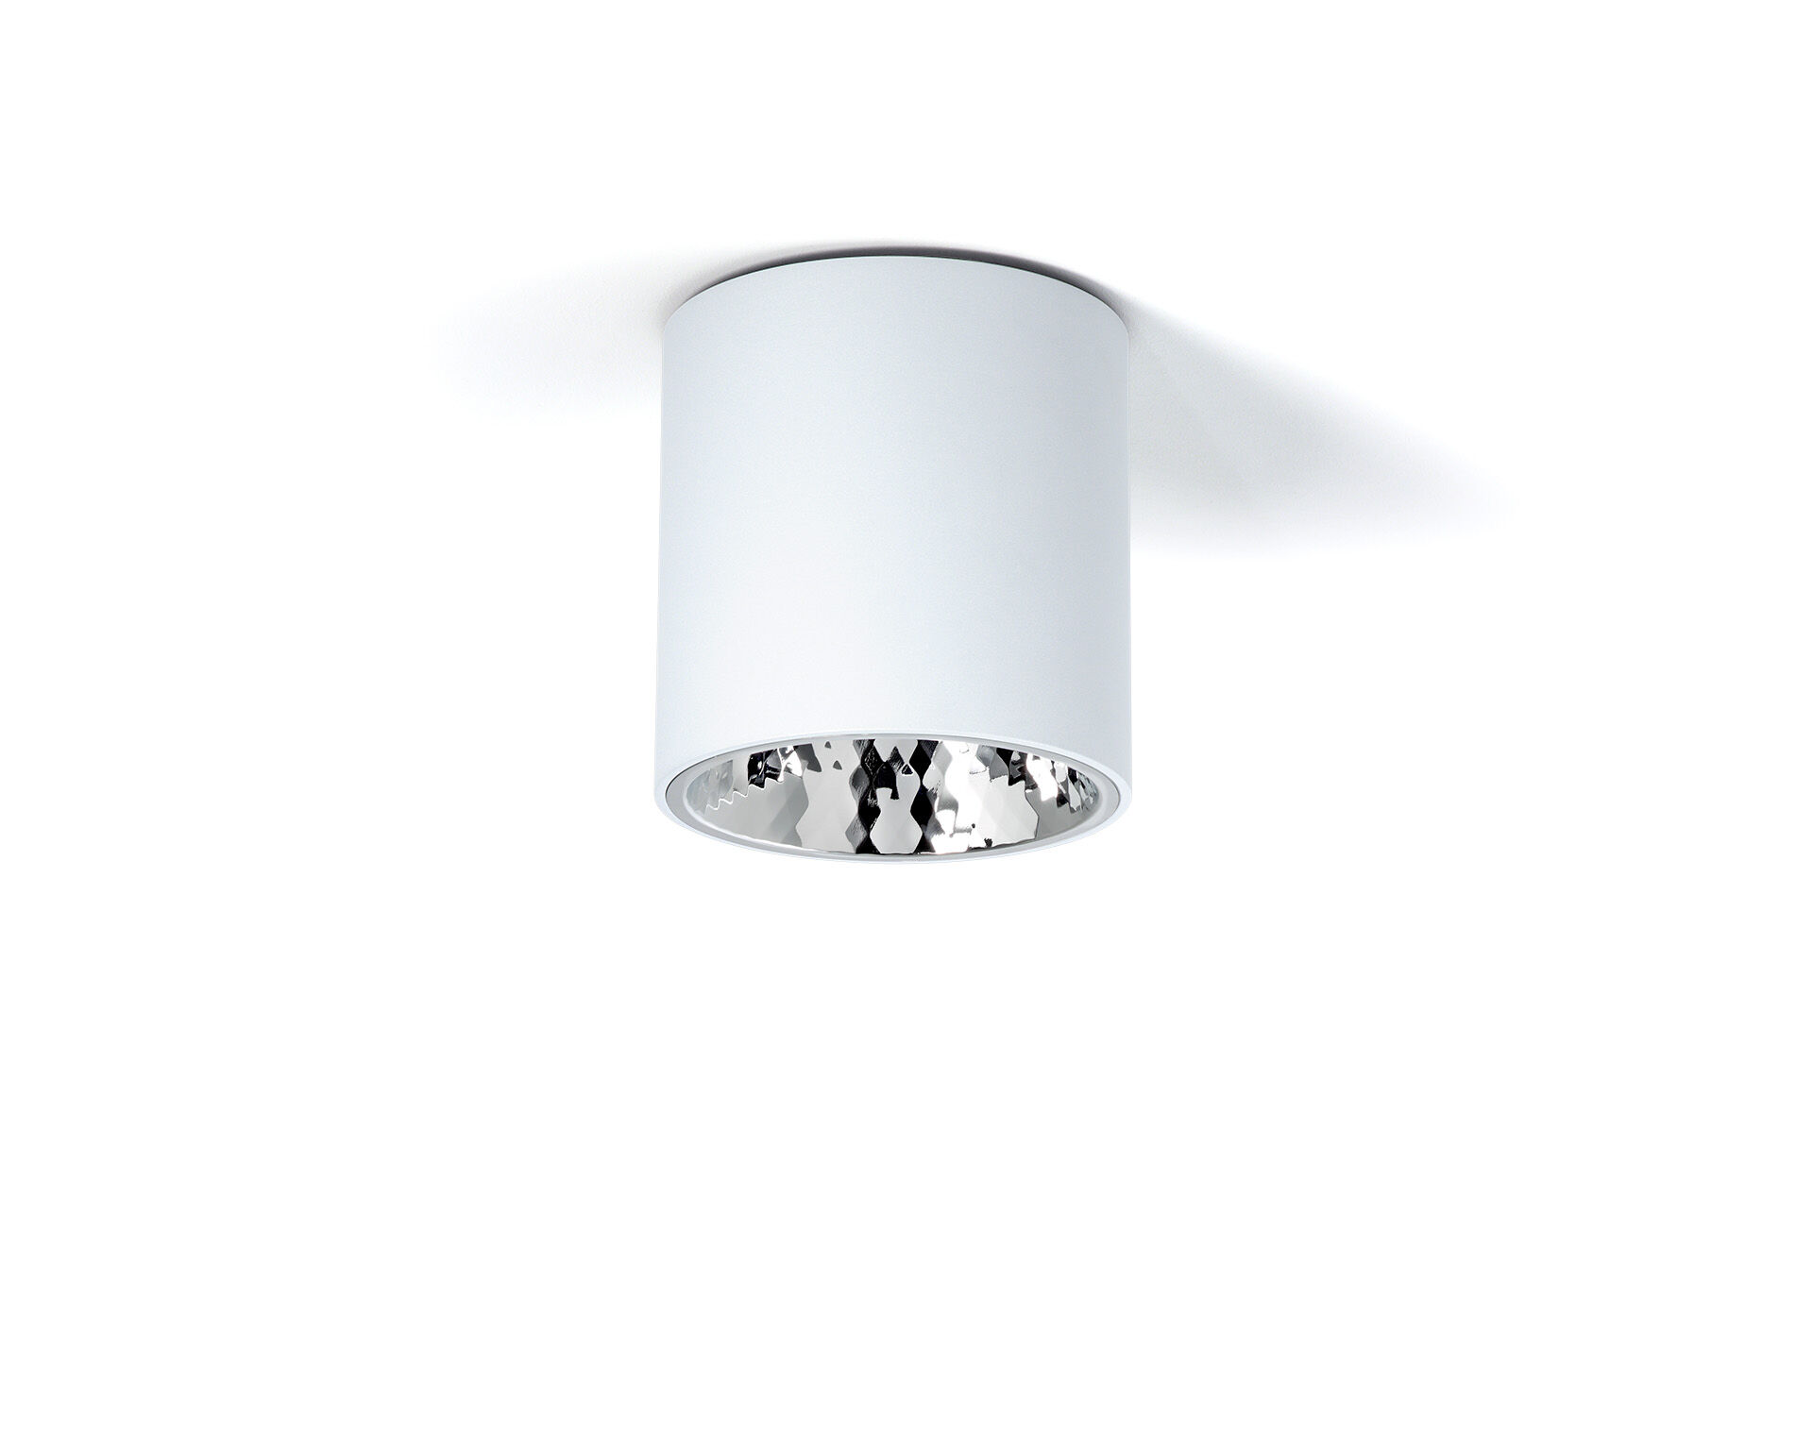
Surface-mounted downlight with aluminium reflector. Reflector optics, aluminium, specular with diamond facets, medium wide-angle light distribution. Aluminium cylindrical housing, other RAL colours possible on demand. Dimensions: Ø 200 mm x 212 mm. Individual round Reflector shields the light source thus preventing glare from the LED source. Wide-angle light distribution. Luminous flux: 1500 lm, Luminous efficacy: 150 lm/W. Power: 10.0 W, DALI dimmable. Frequency: 50Hz AC. Voltage: 230-240V. Electrical isolation class: class I. LED with very good light maintenance; at 50000 hrs the luminaire retains 96% of it's initial flux (Tq=25°C). Correlated colour temperature: 4000 K, Colour rendering ra: 80. Colour consistency (McAdam ellipse): ≤ 3 SDCM. Photobiological safety IEC/TR 62778: RG1. Lacquered aluminium housing, RAL9003 - white. Replaceable (LED only) light source by a professional. Replaceable control gear by a professional. Energy efficiency class of the light source according to EU regulation 2019/2015: D. 5 years warranty on luminaire and driver. Certifications: CE, ENEC. Luminaire with halogen free leads. The luminaire has been developed and produced according to standard EN60598-1 in a company that is ISO9001 and ISO14001 certified.

