K212/3

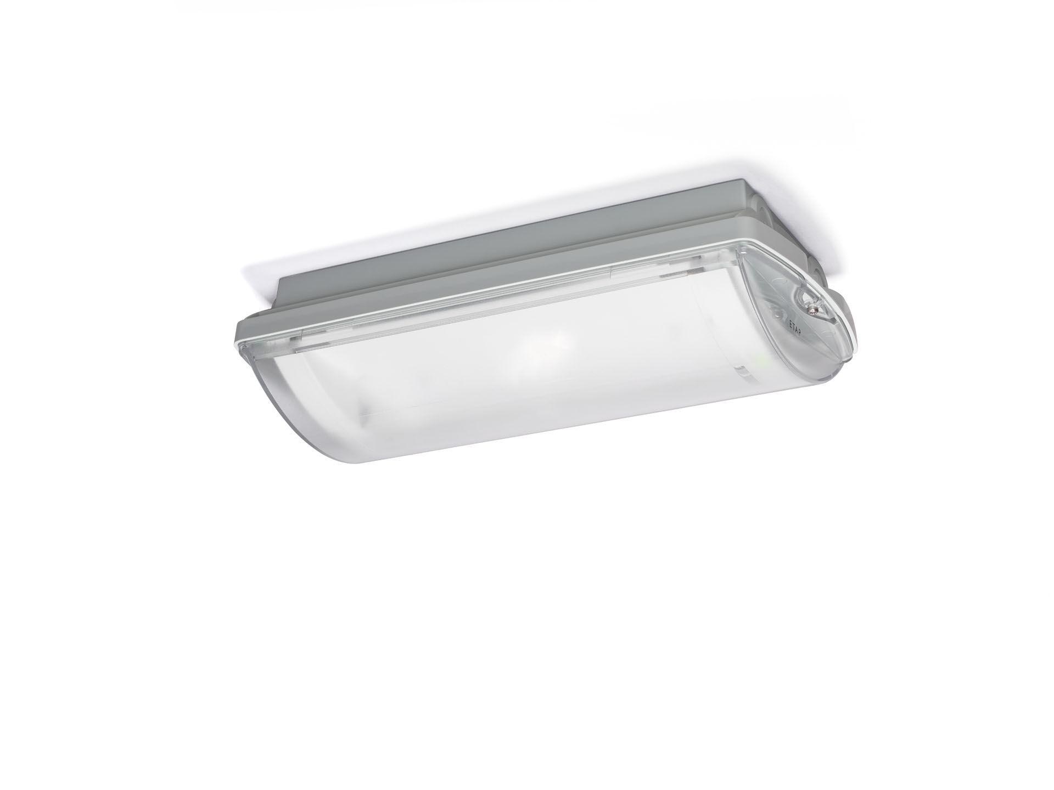
- IP65 emergency luminaire for escape route lighting. Surface mounted.
- Autonomous luminaire (contains battery).
- Dimensions: 359 mm x 180 mm x 100 mm.
- Mounted on two stainless steel clamps, automatic electrical connection screwless wire terminals (up to 2.5 mm²), cable gland included, through-wiring possibility, optional accessories for recessed mounting
- Line-shaped light distribution, optimized for 1 lux along the escape route axis.
- Lumen output in emergency mode: 275 lm.
- Power consumption in standby: 0.9 W.
- Inderdistance escape route: at a mounting height of 2.8 m, the illumination on the floor is 1 lux with an interdistance ("b") of 20.5 m.
- Voltage: 220-230V.
- Autonomy: 60 minutes. The luminaire contains lamp data, battery date and type as required according to EN 60598-2.22.
- Battery: 4 x NiMh 1,2V 1,1Ah.
- Automatic functional test every week, duration test every 13 weeks, in accordance to EN 50172 and EN 62034.
- Maintained/non maintained mode selectable, preset for most common application.
- Electrical insulation class: class II.
- Photobiological safety IEC/TR 62778: RG1.
- Impact-resistant polycarbonate housing, RAL9018 - papyrus white.
- IP protection level: IP65.
- IK protection level: IK10.
- Ambient temperature: 5°C - 35°C.
- Glowwire: 850°C.
- 5 years warranty on luminaire, light source, driver and battery (for autonomous luminaires).
- Certifications: CE, ENEC.
- The luminaire has been developed and produced according to standard EN60598-1 in a company that is ISO9001 and ISO14001 certified.

