K1R163/1S11

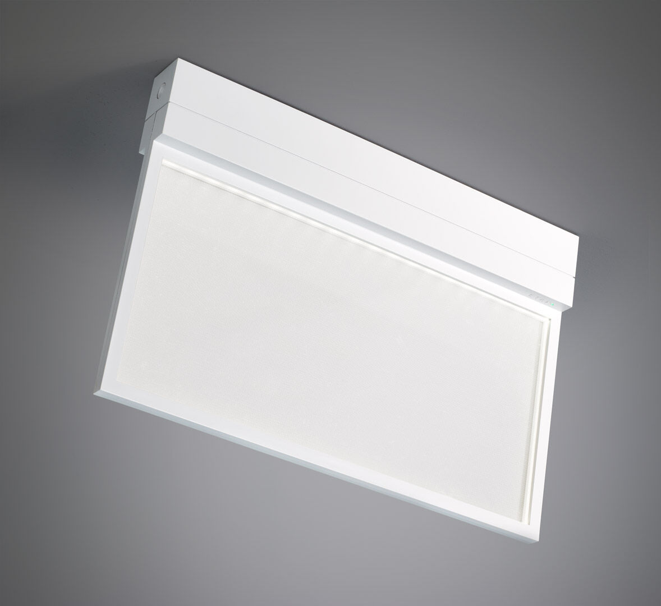
- Emergency luminaire with comfortable diffuse lighting. Surface mounted.
- Autonomous luminaire (contains battery).
- Dimensions: 315 mm x 33 mm x 219 mm.
- Diffusor plate light source for comfortable illumination. Polycarbonate housing, screwless opening, automatic electrical connection, screwless wire terminals (up to 2.5 mm²), suited for ceiling and wall mounting, optional accessories for recessed or suspended mounting.
- Lumen output in emergency mode: 200 lm.
- Power consumption in standby: 0.8 W.
- Voltage: 220-230V.
- Autonomy: 60 minutes. The luminaire contains lamp data, battery date and type as required according to EN 60598-2.22.
- Battery: 4 x NiMh 1,2V 1,1Ah. Battery lifetime: 10 years.
- Automatic functional test every week, duration test every 13 weeks, in accordance to EN 50172 and EN 62034. Monitoring and control via DALI for central maintenance. Connection via two wire BUS communication.
- Maintained/non maintained mode selectable, preset for most common application.
- Electrical insulation class: class II.
- Photobiological safety IEC/TR 62778: RG0.
- Impact-resistant polycarbonate housing, RAL9003 - signal white.
- IP protection level: IP42.
- IK protection level: IK04.
- Ambient temperature: 5°C - 35°C.
- Glowwire: 850°C.
- 5 years warranty on luminaire, light source, driver and battery (for autonomous luminaires).
- Certifications: CE, ENEC.
- The luminaire has been developed and produced according to standard EN60598-1 in a company that is ISO9001 and ISO14001 certified.

