D91/LEDN20SX1

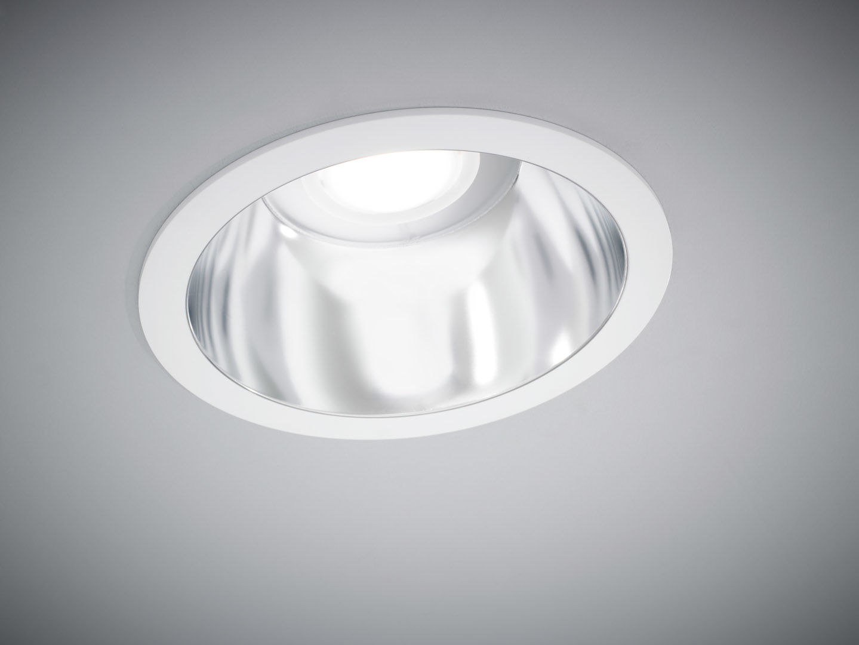
- Seamless polycarbonate downlight.
- Reflector and lens optics, polycarbonate (PC) with aluminium thin film, satin look, wide-angle light distribution.
- White polycarbonate trim and reflector form one unit, without visible seams.
- Dimensions: Ø 190 mm x 100 mm.
- Ceiling cut-out: Ø 175 mm.
- Reflector shields the light source and a lens prevents glare.
- Luminous flux: 2150 lm, Luminous efficacy: 116 lm/W.
- Power: 18.5 W, not dimmable.
- Frequency: 50-60Hz AC/DC.
- Voltage: 220-240V.
- Electrical isolation class: class I.
- LED with very good light maintenance; at 50000 hrs the luminaire retains 98% of it's initial flux (Tq=25°C).
- Correlated colour temperature: 4000 K, Colour rendering ra: 80.
- Standard deviation colour matching satisfy 3 SDCM.
- Photobiological safety IEC/TR 62778: RG1.
- Polycarbonate housing, RAL9003 - signal white.
- IP protection level: IP20.
- Glowwire: 850°C.
- 5 years warranty on luminaire and driver.
- Certifications: CE, ENEC.
- Luminaire with halogen free leads.
- The luminaire has been developed and produced according to standard EN60598-1 in a company that is ISO9001 and ISO14001 certified.

